**The 6 Essential Principles of Leadership Coaching**



You may be pretty familiar — and probably fairly comfortable — with the model of the visiting leadership coach. Sometimes it’s easier to dispense leadership advice to an audience you don’t know. So it’s no wonder these leadership pros seem so confident. But what if *you’re* asked to coach a subordinate or a peer within your organization? Is coaching someone you might work with daily an impossible task?

**Six Core Leadership Coaching Principles**

Whether you’re an outside executive coach or a leader-coach working in the trenches of your organization, a lot of the same rules of thumb apply in terms of what it takes to coach your people.

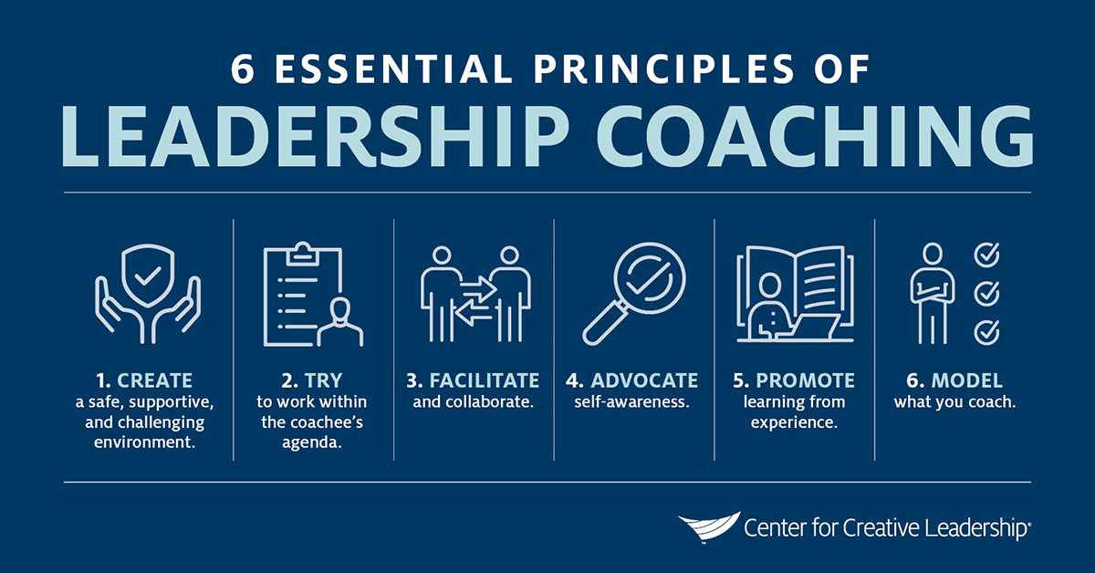

Use these 6 core principles for leadership coaching to coach someone from an office or cubicle near you:

1. **First, create a safe and supportive, yet challenging environment.**We all need our thinking challenged at times. But offered without sufficient support, challenge can cause damage by decreasing trust and eroding morale. Providing safety and support includes assuring people that they’ve been heard and that their feelings and values are understood. It builds trust, encourages honesty and candour, and helps your coachee feel psychologically safe at work. It’s up to you to create an environment where risk-taking feels rewarding, not risky, so keep your attitude as open and as non-judgmental as possible, and let the coachee know you support them, even as you test their knowledge and skills. (This is the basis of our *Assessment – Challenge – Support (ACS)™*framework; remember ACS to ensure you’re providing needed support at the same time as accountability.)
2. **Try to work within the coachee’s agenda.** Remember, this coaching session is not about you, so let the coachee decide which goals to work on and even how to go about improving. Sure, it’s great when the coachee’s own agenda aligns perfectly with the organization’s goals, but never impose your personal priorities on the relationship. When it’s clear you need to push a point, put on your managerial hat — thereby preserving the special collaborative coaching relationship you’re trying so hard to build.
3. **Facilitate and collaborate.** Like Socrates, who always led his students with questions, the best coaches don’t give direct answers or act the expert. To hold a coaching conversation, focus on the coachee’s needs, and avoid filling the lesson with your own life stories and pet theories. Although you may suggest several options for responding to a problem, the ultimate choice should rest with the coachee — with you acting as the facilitator and collaborator.
4. **Advocate self-awareness.** You want your coachee to learn how to recognize their own strengths and present weaknesses — a prerequisite skill for any good leader. In the same way, you should understand how your own behaviours as a coach impact the people around you. Demonstrate a sense of awareness in yourself and you’re more likely to foster in your coachee a similar self-awareness. You may also want to share ways to boost self-awareness.
5. **Promote learning from experience.** Most people can learn, grow, and change only if they have the right set of experiences and are open to learning from them. As a coach, always help your coachee reflect on past events and to analyse what went well and what didn’t. Foster experiential learning and using experience to fuel development, and your student will continue to improve long after the end of your lessons.
6. **Finally, model what you coach.** This, the last of the 6 core principles of coaching, may be the most difficult to embody, as it means putting into practice outside of class the leadership lessons you’ve been trying to communicate.

And remember, if you don’t feel you have the capacity to coach on a particular issue, refer your coachee to someone more experienced — perhaps somehow who, we hope, puts into practice the 6 core leadership coaching principles even better than you do.

Leading Effectively – March 2020

From: [The 6 Essential Principles of Leadership Coaching | CCL](https://www.ccl.org/articles/leading-effectively-articles/the-six-principles-of-leadership-coaching/)